OFFICIAL LEAGUE ROSTER – BASKETBALL
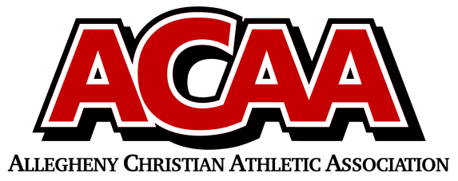

School: Belleville Christian School Head Coach: Chase Peachey
Date: __________________________ Assist. Coach: Nate Metzler
Assist Coach: Mike Ammon

2025-2026 BCS Boys Varsity Basketball

Name Grade Position Height Jersey #
Dakota Gibbons 12 F 5’10” 5
Bryson Peachey 12 G 5’10” 4
Colin Hartzler 11 F 6’3” 51
Ethan Renno 11 G 5’10” 52
Landon Rhodes 11 G 5’10” 10
Grant Yoder 11 F 6’1” 54
Bailey Armstrong 10 F 6’11” 22
Ian Kauffman 10 F 5’10” 43
Devin Yoder 10 G 5’10” 53
Landon Yoder 10 G 5’9” 10
Cade Yoder 9 G 5’9” 50

